4/15/25

Patrick roy elalto
cis 1201 – group 6
UNiversity of san carlos bs it - 1

Dear Sir Patrick,

I am formally writing this apology letter to handle my phone usage today during our Pre-fi test in Programming 2: I was confronted for my phone usage while scrolling through social media during the test while being unfinished.

For the violation, I apologize for not exactly abiding by the rules as my excuse is also not great and maybe even invalid. Simply put, to drown out stress and anxiety at the time, for a while actually, I was scrolling through my Twitter feed and did not stop until I was confronted. This was my escape as my mental state is not very stable and can be vouched for by my parents and the Senior High School department, specifically during my Grade 11 stay. I understand that these violations put a dent in my reputation as a Carolinian and its negative effects on everyone around me. I am open for contact and to discuss further on this topic and if there are any disciplinary actions, I accept.

Moving forward from this, as a student of USC, I shall uphold the rules and regulations closely in order to avoid any more future violations while asking for permission for more inquires that may cross a line, making sure to not cause any harm to anyone around me and to uplift the name of the school and its people.

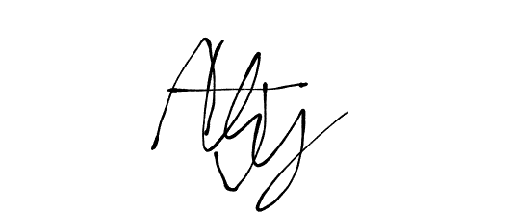Sincerely yours,

Aidan Jeremy Yu Uy___________________________
Student’s signature over printed full name
(22102067, BS IT - 1)
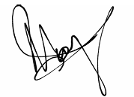
Noted by:

Maria Adelina Uy______________________________
Parent’s/Legal Guardian’s signature over printed name

Patrick Roy Elalto
Class Adviser’s signature over printed name

